**SUMMER TRAINING REPORT**

On

**Disease Prediction**

***Bachelor of Technology***

***In***

***Computer Science & Engineering***

To

**IKG Punjab Technical University, Jalandhar**

**SUBMITTED BY:**

**Name:** VIVEK KUMAR

**Roll no:** 2320379

**Semester: 5th**

**Batch: 2022-2026**

**Under the Guidance**

**Mr.**

## Assistant Professor



## Department of Computer Science & Engineering

**CGC – College of Engineering, Landran**

**Mohali, Punjab – 140307**

**July 2024**

### **CERTIFICATE**

This is to certify that **VIVEK KUMAR** has completed the Summer Training during the period from ………… to ………..2024 in our Organization as a Partial Fulfilment of Degree of

Bachelor of Technology in Computer Science & Engineering.

**(Signature of Project Supervisor)**

**Date: 020-06-2024**

#### **CANDIDATE DECLARATION**

I hereby declare that the Project Report entitled **DISEASE PREDICTION** is an authentic record of my own work as requirements of 8th semester academic during the period from **..29.. May 2024** to **26th June 2024** for the award of degree of B.Tech. (Computer Science & Engineering, College of Engineering- CGC, Landran , Mohali.

**Date: 26-06-2024**

**(Signature of student)**

#### (VIVEK KUMAR) (2320379)

Certified that the above statement made by the student is correct to the best of our knowledge and belief.

**Course Coordinator Head of Department**

**(Signature and Seal)**

### **ACKNOWLEDGEMENT**

I take this opportunity to express my sincere gratitude to the principal CGC College of Engineering, Landran for providing this opportunity to carry out the present work.

I am highly grateful to the Dr. Sushil Kamboj HOD CSE, CGC College of Engineering, Landran (Mohali), for providing this opportunity to carry out the six-month industrial training at …**SOLIATIRE INFOSYS PVT LTD, MOHALI**…. I would like to express my gratitude to other faculty members of Computer Science & Engineering department of CGC COLLEGE OF ENGINEERING Landran for providing academics inputs, guidance & encouragement throughout the training period. I would like to express a deep sense of gratitude to all who have directly or indirectly contributed to successful completion of my industrial training.

VIVEK KUMAR

2320379

|  |  |  |
| --- | --- | --- |
| **S. No** | **TOPIC** | **Page No.** |
| 1 | Executive Summary | 6 |
| 2 | Introduction | 7-8 |
| 3 | Project Scope | 9-10 |
| 4 | Methodology | 11-12 |
| 5 | Implementation | 13 |
| 6 | Project Management | 14 |
| 7 | Outcomes and Results | 15-18 |
| 8 | Challenges and Lessons Learned | 19-20 |
| 9 | Future Recommendations | 21-23 |
| 10 | Appendices | 24-25 |

**WEB DESIGNING PROJECT REPORT**

1. **Executive Summary**

* **Project Title:** Disease prediction
* **Project Duration:** 1 week
* **Date of Report:** June 25, 2024
* **Prepared by:** Vivek, Chahat, Nitish
* **Overview:** The Diabetes Prediction Web Application project focuses on predict the likelihood of an individual developing disease based on their BMI, age, and other health parameters. This initiative aims to provide users with a convenient tool to assess their potential risk of their disease through a user-friendly web interface. By merging technology with healthcare analytics, this project promotes health awareness and proactive management. It empowers users to make informed decisions about their health based on personalized risk assessments. Gather a large dataset of patient information, including symptoms, medical history, lab test results, and other relevant data. This project aims to revolutionize healthcare by providing a web app for quick, accurate, and personalized disease predictions. It covers diseases such as diabetes, heart disease, Parkinson’s, and also checks the BMI.



**2. Introduction:**

Project Background: The background of this project is rooted in the increasing prevalence and impact of chronic health conditions such as diabetes and cognitive disorders on global public health. By focusing on both diabetes and brain health, the project aims to provide a comprehensive health assessment tool. It leverages predictive models to estimate individual risks based on various factors such as BMI, age, lifestyle habits, and potentially genetic predispositions.

Objective:

Development of User Interface (UI):

* Create intuitive web pages using HTML for structure and CSS for styling.
* Ensure responsiveness across various devices to enhance accessibility.

User Interaction and Feedback:

* Design forms to collect user data such as age, BMI, and relevant health metrics.
* Display prediction results in a clear and understandable format on the web page.

Purpose of the Project:

* Integrated Health Assessment: By focusing on both diabetes and brain health, the project aims to provide a comprehensive health assessment tool. It leverages predictive models to estimate individual risks based on various factors such as BMI, age, lifestyle habits, and potentially genetic predispositions.
* Empowerment Through Technology: The project seeks to empower individuals by offering accessible, user-friendly tools that promote health awareness, encourage proactive health management, and facilitate informed decision-making.
* Contribution to Public Health: By promoting early detection and preventive strategies, the project contributes to reducing the overall burden of chronic diseases on healthcare systems and society.
* **Personalized Recommendations**: Disease prediction platforms provide personalized recommendations based on user data. These may include lifestyle modifications, screenings, or specific medical tests. Personalization ensures that interventions are tailored to everyone’s unique needs.
* **Enhancing Precision**: Disease prediction websites aim to provide accurate predictions based on symptoms, risk factors, or health data. By leveraging machine learning models, these platforms enhance the precision of individual disease predictions
* **Comprehensive Understanding:** Beyond individual disease predictions, some websites offer insights into potential comorbidities. This comprehensive understanding helps healthcare practitioners make informed decisions.
* **Revolutionizing Patient Care:** Disease prediction tools can revolutionize patient care by enabling early detection and personalized prevention strategies. They contribute to improving medical efficiency, reducing costs, and enhancing clinical decisions.

**3. Project Scope:**

* **Constraints:**
* Timeline**:** A strict 1-week deadline for project completion.
* Technical Restrictions**:** Negligible access to backend technologies, relying solely on frontend solutions for streaming.
* **Website Development:**
  + Design and development of a responsive website using HTML, CSS, and JavaScript.
  + Implementation of a user-friendly interface with intuitive navigation for easy access **to information.**
* **Interactive Elements:**
  + Integration of interactive features such as filling your details to get to know your disease chance with visual meter.
* **Launch and Maintenance**
  + Planning for the website launch, including promotional activities to increase visibility.
  + Establishment of a maintenance plan for ongoing updates, content additions, and technical support.
* **Problem Definition**:
  + Clearly define the problem you want to address. Are you predicting a specific disease (e.g., diabetes, cancer, heart disease), or do you want a multi-disease prediction system?
  + Specify the target audience (patients, healthcare providers, researchers).
* **Data Collection and Preprocessing**:
  + Gather relevant data. This includes symptoms, risk factors, medical history, and other relevant features.
  + Clean and preprocess the data to ensure its quality.
* **Model Selection and Training**:
  + Use the JavaScript to provide functionality to predict the disease.
* **User Interface and Deployment**:
  + Develop a user-friendly interface (website) where users can input symptoms or risk factors.
  + Deploy the trained model to make real-time predictions.
* **Ethical Considerations**:
  + Ensure fairness and transparency in predictions.
  1. **Methodology:**
* Research and Analysis

Conduct interviews with a diverse sample of potential users, including individuals at risk of diabetes, healthcare professionals, and caregivers.

Identify and gather datasets or sources of information relevant to the project objectives

Some key questions like:

1. What are the primary health concerns of users related to diabetes, heart disease, BMI, and brain health?

2.How do users currently monitor or manage their health risks?

* Design Process

UI/UX Design:

* Create wireframes and prototypes of the user interface (UI) to visualize the flow of information and user interactions.
* Incorporate principles of user experience (UX) design to ensure the interface is intuitive, accessible, and aligns with best practices in health-related applications.
* Development
* Front-end Development:
* Implement the UI design using HTML, CSS, and JavaScript to create responsive and visually appealing web pages.
* Integrate form elements for collecting user inputs related to BMI, age, glucose level, etc.
* **Enhancing Precision**:
  + Disease prediction websites aim to provide accurate predictions based on symptoms, risk factors, or health data.
  + These platforms enhance the precision of individual disease predictions.
* **Comprehensive Understanding**:
  + Beyond individual disease predictions, some websites offer insights into potential comorbidities.
  + This comprehensive understanding helps healthcare practitioners make informed decisions.
* **Data Gathering**:
  + Start by collecting relevant data. In the context of disease prediction, this data typically includes symptoms, risk factors, and patient information.
* **Data Preparation and Cleaning**:
  + Clean the data to ensure its quality. Remove any null values, outliers, or inconsistencies.
  + Encode categorical features (like disease labels) into numerical form using techniques like label encoding.
* **Ensemble Prediction**:
  + Combine predictions from multiple models to enhance accuracy.
* **Deployment and Interface**:
  + Create a user-friendly interface (website) where users can input symptoms.
  + The system processes the input, predicts the disease, and returns results.

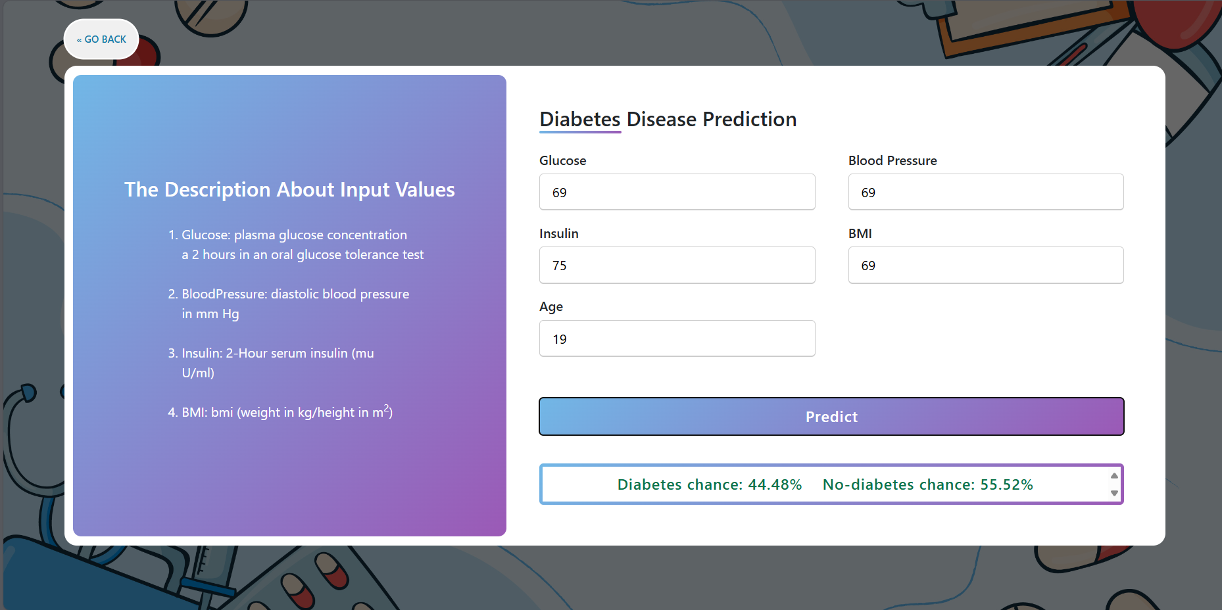

**5. Implementation:**

* FOR WEBSITE STRUCTURE: We used HTML which provides structure to the web page.
* HTML, or **Hypertext Markup Language** is the standard markup language used to create web pages. It is a combination of Hypertext and Markup language. The Hypertext defines the link between web pages, and Markup defines the text document within tags to structure the web pages. This language annotates text so that machines can understand and manipulate it accordingly. HTML is human-readable and uses tags to define what manipulation has to be done on the text.
* FOR STYLING: We used CSS which makes the web page attractive and user-friendly.
* CSS (Cascading Style Sheets) is a language designed to simplify the process of making web pages presentable. It allows you to apply styles to HTML documents, describing how a webpage should look by prescribing colors, fonts, spacing, and positioning. CSS provides developers and designers with powerful control over the presentation of HTML elements.
* FOR FUNCTIONALITY: We used JavaScript to provide output of the given input.
* A Script is a small program which is used with HTML to make web pages more attractive, dynamic and interactive, such as an alert popup window on mouse click.
* **Launch:**
* Download and unzip the project folder.
* Open the folder using a code editor such as vs code.
* Run the index.html file.
* You will be successfully able to explore the functionalities using your default browser.

**6. Project Management:**

* Timeline
* Project Kick-off and Planning (Day 1)
* Define project scope, goals, and requirements for the front-end development.
* Allocate resources and establish a timeline for the project.
* Design and Wireframing (Day 2-3)
* Create wireframes and initial mock-ups based on project requirements.
* Gather feedback from stakeholders and finalize design direction.
* Front-End Development (Day 4-6)
* Implement UI/UX components using HTML, CSS, and JavaScript.
* Ensure responsive design and cross-browser compatibility.
* Testing and Debugging (Day 7)
* Conduct thorough testing of front-end functionalities, including UI responsiveness and usability.
* Identify and address any bugs or issues.
* And after fixing the bugs or issues, we completed the project.
  1. **OUTCOMES AND RESULTS:**
  + **Achievements**
* **Accuracy and Precision**:
  + The accuracy of a disease prediction model is crucial. It measures how often the model’s predictions match the actual outcomes.
  + Precision is equally important. It assesses the proportion of true positive predictions (correctly predicted cases) among all positive predictions.
  + A balance between accuracy and precision is essential. High accuracy with low precision can lead to false positives, affecting patient care.
* **Early Detection**:
  + Disease prediction models aim to detect diseases early, even before noticeable symptoms appear.
  + Early detection allows for timely intervention, potentially improving treatment outcomes.
* **False Positives and False Negatives**:
  + False positives occur when the model predicts a disease that doesn’t exist. These can lead to unnecessary stress and medical procedures.
  + False negatives occur when the model misses an actual disease. These can delay necessary treatment.
  + Minimizing both types of errors is a challenge.
* **Personalized Prevention Strategies**:
  + Disease prediction tools provide personalized risk assessments.
  + Users receive recommendations based on their specific risk factors (e.g., lifestyle, genetics, age).
  + These strategies can include lifestyle changes, screenings, or preventive medications.
* **Challenges and Limitations**:
  + Data quality affects model performance. Incomplete or biased data can lead to inaccurate predictions.
  + Rare diseases pose challenges due to limited data availability.

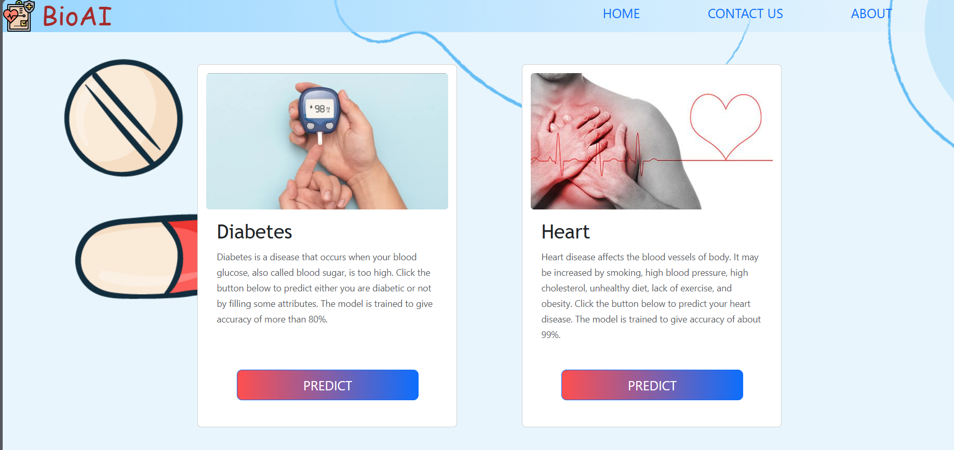

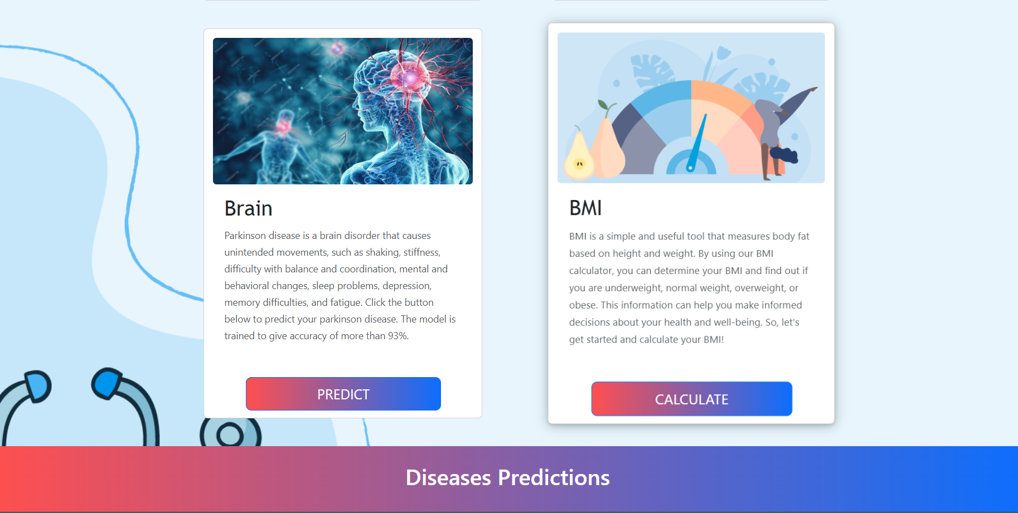

Before input

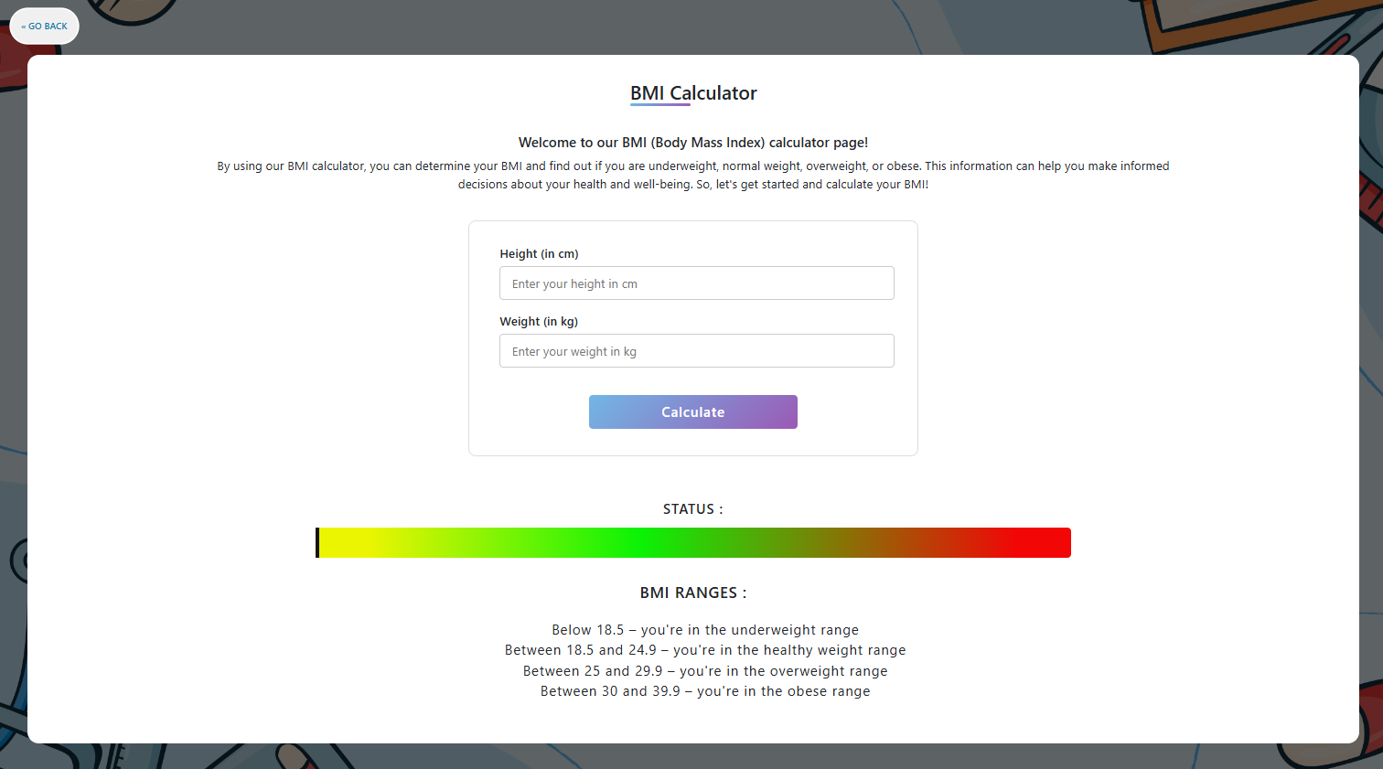

After input

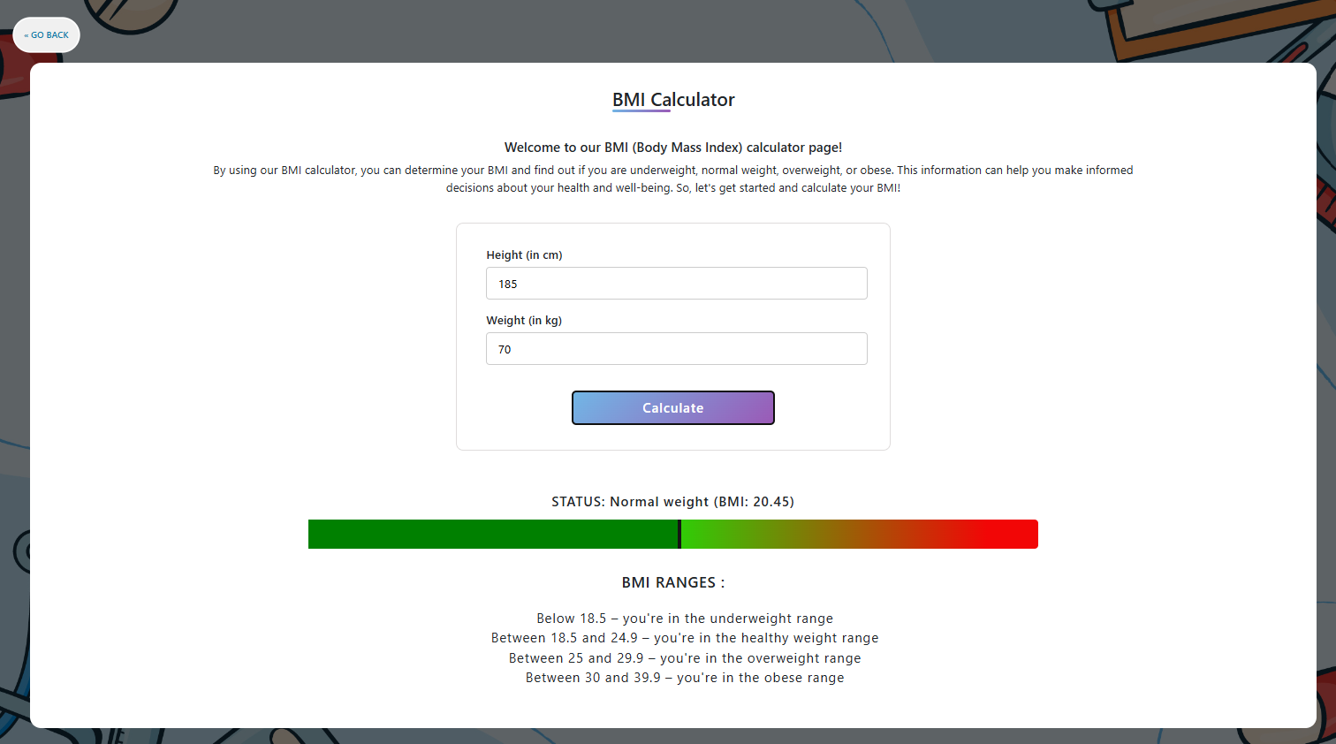

**8. Challenges and lessons learned:**

* **Challenges**
  + Time Constraints
* Managed through Agile methodology with daily stand-ups for progress tracking and quick issue resolution.
  + Design Iterations
* Addressed with clear communication and rapid iteration cycles based on stakeholder feedback to streamline decision-making.
  + Cross-Browser Compatibility
* Mitigated early with thorough testing and use of responsive design frameworks like Bootstrap for consistent performance across browsers.
  + Resource Limitations
* Overcame by prioritizing tasks, leveraging existing skills, and optimizing team productivity to meet project milestones.
  + User Experience Optimization
* Achieved through iterative usability testing and continuous refinement of UI/UX design to ensure intuitive navigation and accessibility.
* **Lessons Learned**
  + Agile Methodology
* Adaptability and iterative development are key for managing changing project dynamics and meeting deadlines.
  + User Experience
* Focus Prioritizing user feedback and iterative design enhances usability and adoption rates.
  + Collaborative Approach
* Effective communication and teamwork across disciplines streamline processes and accelerate project timelines.
  + Technical Rigor
* Early testing for compatibility and performance ensures robustness and reliability in project delivery.
  + Resource Efficiency
* Optimal resource allocation and task prioritization maximize productivity despite constraints.
  + Continuous Learning
* Embracing a growth mindset and fostering a culture of improvement drive innovation and project success.

**9. Future Recommendations:**

* + **Enhanced Data Collection**:
  + Collect more diverse and comprehensive health data. Include genetic information, lifestyle factors, and environmental exposures.
  + Collaborate with healthcare institutions, research centres, and wearable devices to gather real-time data.
  + **Deep Learning Architectures**:
  + Explore deep learning models (e.g., convolutional neural networks, recurrent neural networks) for disease prediction.
  + These architectures can capture complex patterns and temporal dependencies.
  + **Transfer Learning**:
  + Leverage pre-trained models (e.g., BERT, GPT) for disease prediction.
  + Fine-tune these models on medical data to benefit from their generalization capabilities.
  + **Explainable AI**:
  + Develop interpretable models to gain insights into prediction decisions.
  + Techniques like SHAP (Shapley Additive Explanations) can help explain feature importance.
* **Collaboration with Clinicians**:
  + Involve healthcare professionals in model development.
  + Their domain expertise ensures clinical relevance and practical usability.
* **Ethical Considerations and Bias Mitigation**:
  + Address bias in data collection and model training.
  + Regularly audit models for fairness and equity.
* **Enhanced Features**
* Consider adding advanced features such as personalized user accounts, product reviews, and recommendation engines to enrich user engagement and retention.
* **Mobile Optimization**
* Prioritize further optimization for mobile devices to cater to the increasing number of users accessing the website via smartphones and tablets.
* **Customer Support**
* Enhance customer support options, including live chat or AI-powered chatbots, to provide real-time assistance and improve overall customer satisfaction.
* **Security Enhancements**
* Continuously update security measures, including regular audits, to safeguard user data and protect against evolving cybersecurity threats.
* **Feedback Mechanism**
* Establish a structured feedback mechanism to gather insights from users regularly, allowing for iterative improvements based on customer preferences and needs.
* **Cybersecurity and Data Privacy**
* Continuous Monitoring: Regularly update cybersecurity measures and conduct vulnerability assessments to protect user data and maintain compliance with data privacy regulations.
* **User Education**
* Educate users about data protection practices and privacy policies, fostering trust and transparency in handling personal information

**10. Appendices:**

* **Supporting Documents**
* User Survey Report
* Summarizing findings from user surveys, including feedback on website usability, features, and overall satisfaction.
  + Design Mock-ups and Wireframes
* Visual representations of website layout, UI elements, and navigation flow.
  + Technical Specifications
* Detailed documentation outlining front-end and back-end technologies, system architecture, and integration requirements.
  + Marketing Plan
* Details digital marketing strategies and campaigns to promote the website and attract traffic.
  + Training Materials
* Guides and manuals for client teams on website management, content updates, and basic troubleshooting.
  + Analytics and Insights
* Report provides analysis of website performance metrics, user behaviour, and trends to inform future optimization efforts.
* **Feature Selection Techniques**:
  + When building a disease prediction model, selecting relevant features (input variables) is crucial.
* **Ensemble Methods**:
  + Combine predictions from multiple models to improve overall accuracy.
  + Examples include bagging (Bootstrap)
* **Model Deployment**:
  + Deploy the trained model as a website
  + Ensure scalability, security, and real-time predictions.
* **References**
* W3Schools (https://www.w3schools.com/)
* Bootstrap (https://www.getbootstrap.com/)
* Google Developers (https://developers.google.com/)